Maths L1 Refresh

Pie Charts

1 of 16 – Introduction
Welcome to this session on pie charts.
By the end of this session, you will be able to:
- Explain how a pie chart displays information
- Extract information from a pie chart
- Interpret information from a pie chart
- Use data from a table to create a pie chart

2 of 16 – Pie charts
Pie charts are useful for indicating the relative proportions of the various components that make up a whole. The “slices” of pie charts, called sectors, are used to show the relative size of data.
- Pie charts are useful because:
- They present information in clear, systematic way
- Some people take in visual information more clearly and quickly than words
- It is easier to see relationships, patterns or trends
- You can make comparisons more easily
Pie charts present information in a way that can be taken in visually all at once. However, it can be difficult to compare if different sectors are similar in size.

3 of 16 – Understanding pie charts
The whole pie chart represents the total data measured. In the example on the right, the whole pie chart represents the world population, and each sector represents a proportion of the whole.
Pie charts should always have a clear title, and should be easy to read and understand.
A pie chart must always be labelled. This can be done by labelling each sector, or using a key. This example uses both methods.
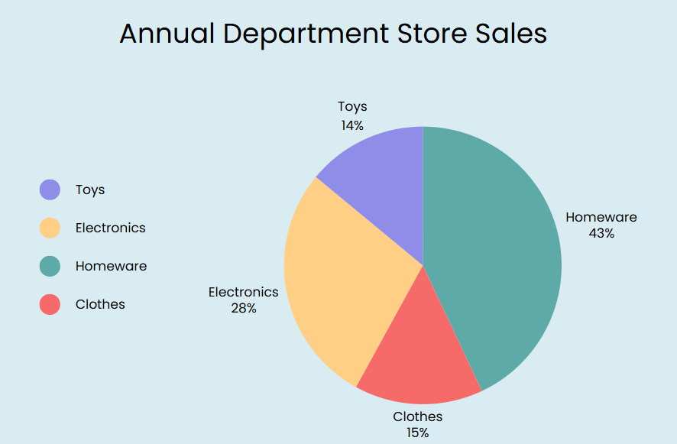

4 of 16 - How to read a pie chart
Each slice of the pie chart represents its category’s proportion of the total information. Each slice is proportional in size to the percentage of the total that it represents.
Sometimes, the pie chart will be labelled to show you the amount represented by each section. This could be a number or a percentage.
In this example, you can see that 20% of the people who responded liked grapes best.
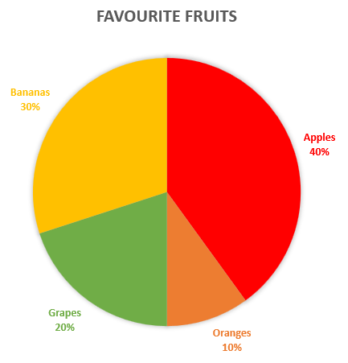
You can also look at the relative sizes of the slices for information. For example, even without the numbers you could tell that more people liked bananas than oranges.

5 of 16 - Answer questions using pie charts
You can use a pie chart to answer a question by interpreting the information that it contains.
In this survey, which was the most popular fruit?
To answer this question, look for the biggest slice on the pie chart. That is apples, so apples are the most popular fruit.
Which fruits were less popular than bananas?
To answer this question, look for the slices which are smaller than the bananas slice. Grapes and oranges have smaller slices that bananas, so they were less popular.

6 of 16 - Question 1
A group of 30 people were surveyed to find their favourite season of the year.
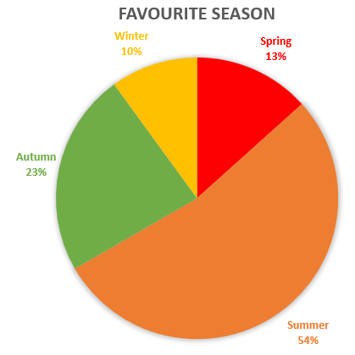
Which season was the most popular?
Select one answer.
- Spring
- Summer
- Autumn
- Winter
Answer:
Summer is the most popular season.

7 of 16 – Question 2
A group of 30 people were surveyed to find their favourite season of the year.
Which season was the least popular?
Select one answer.
- Spring
- Summer
- Autumn
- Winter
Answer:
Winter is the least popular season.

8 of 16 – Question 3
A group of 30 people were surveyed to find their favourite season of the year.
Which of these statements are true?
Select all that apply.
- The same number of people preferred winter and spring
- More people preferred winter than autumn
- Over half of the people surveyed preferred summer
- More people preferred autumn than spring
Answer:
The true statements are; over half of the people surveyed preferred summer and more people preferred autumn than spring

9 of 16 - How to draw a pie chart
To draw a pie chart, we follow these steps:
- Put all your data into a table, and work out how many items you have in total
- Work out what percentage of the total each category represents
- Work out how many degrees each sector, or slice, of the pie chart needs to be
- Draw a circle
- Use a protractor to measure the degrees of each sector and draw them onto the circle
- Colour each sector and give them all labels
- Add a title to the pie chart to describe what it is showing

10 of 16 - Creating a pie chart example
Example: You survey a group of people to find out which is their favourite fruit. 4 people prefer bananas, 5 people prefer raspberries, 6 people prefer apples, 1 person prefers pears and 4 people prefer plums.

Step 1: Put the data in a table and add up all the values to get a total.
Bananas | Raspberries | Apples | Pears | Plums | Total
4 | 5 | 6 | 1 | 4 | 20

Step 2: Divide each value by the total and multiply by 100 to get a percentage.
Bananas | Raspberries | Apples | Pears | Plums | Total
4 | 5 | 6 | 1 | 4 | 20
4/20 x 100 = 20% | 5/20 x 100 = 25% | 6/20 x 100 = 30% | 1/20 x 100 = 5% | 4/20 x 100 = 20% | 100%

Bananas | Raspberries | Apples | Pears | Plums | Total
4 | 5 | 6 | 1 | 4 | 20
4/20 x 100 = 20% | 5/20 x 100 = 25% | 6/20 x 100 = 30% | 1/20 x 100 = 5% | 4/20 x 100 = 20% | 100%
4/20 x 360 = 72° | 5/20 x 360 = 90° | 6/20 x 60 = 108° | 1/20 x 360 = 18° | 4/20 x 360 = 72° | 360°
Step 3: Work out how many degrees are in each sector. There are 360 degrees in a full circle, so we multiply each fraction by 360.

Step 4: Draw a circle

Step 5: Use your protractor to measure the degrees of each sector. Draw the sectors.
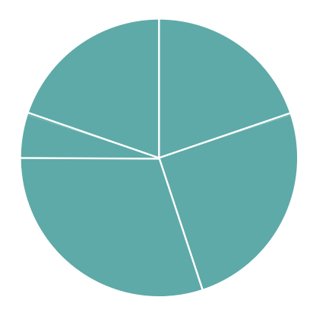
Step 6: Colour each sector and give it a label. For example, the bananas sector could be coloured in yellow, the raspberries sector coloured in red, the apples sector coloured in blue, the pears sector coloured in green and the plums sector coloured in purple.
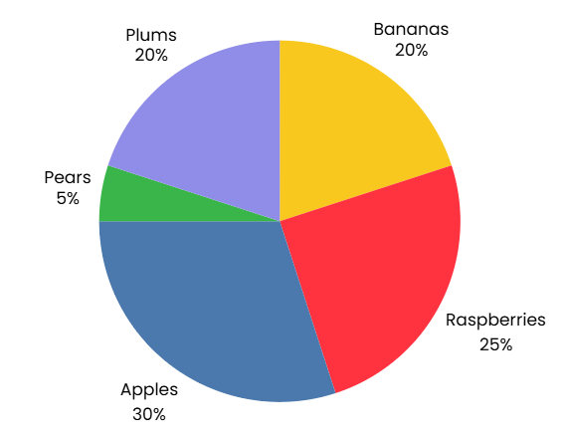
Step 7: Give the pie chart a title. For example, Favourite Fruits.
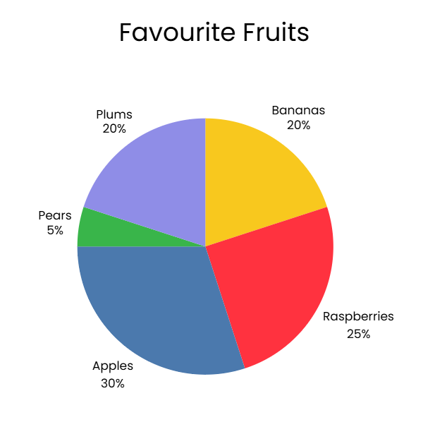

11 of 16 - Question 4
How many people had green cars?
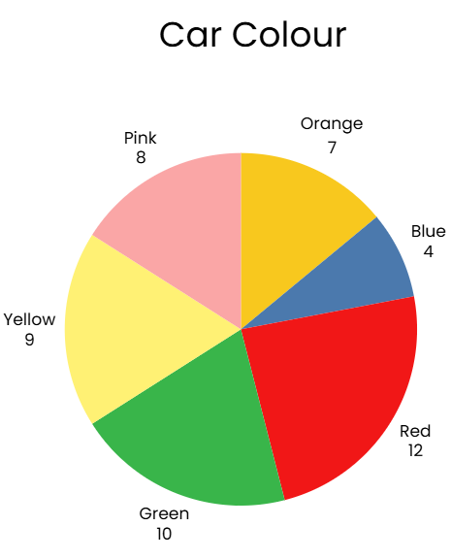
Select one answer.
- 12
- 10
- 9
- 7
Answer:
10 people had green cars.

12 of 16 - Question 5
What was the least popular car colour?
Select one answer.
- Orange
- Red
- Blue
- Pink
Answer:
Blue was the least popular car colour.

13 of 16 - Finding the difference between two temperatures
If you have two pie charts showing related data, you can compare the information shown on them to draw conclusions. For example, look at these two pie charts, showing number of different types of cake slices sold by a café in two consecutive weeks.
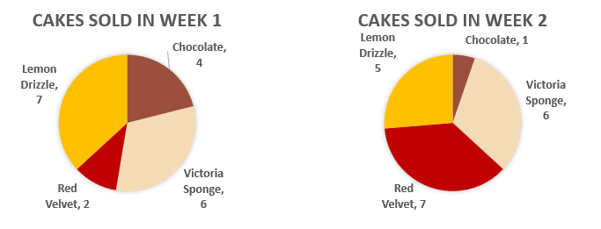
Looking at the two charts next to each other, you can see that red velvet cake was much more popular in the second week, whereas Victoria sponge sold the same amount each week.

14 of 16 – Question 6
Look at these two pie charts, showing information about the waste products generated by a small business in 2020 and 2025. Which of these statements are true?
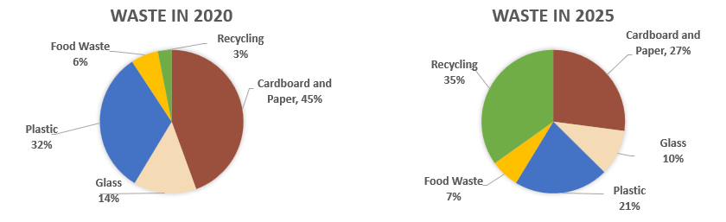
Select all that apply.
- The company recycled more of its waste in 2025 than it did in 2020
- Cardboard and paper was the largest category that is not recycled in both 2020 and 2025
- The company had a lot less food waste in 2025 than they did in 2020
Answer:
According to these pie charts, the two correct statements are:
- The company recycles more of its waste in 2025 than it did in 2020
- Cardboard and paper is the largest category that is not recycled in both 2020 and 2025

15 of 16 – Question 7
Is this statement true or false?
People take in visual information more clearly and quickly than words.
- True
- False
Answer:
This is true. People take in visual information more clearly and quickly than words. Pie charts are useful because they present information in a visual way.

16 of 16 – Conclusion
Well done. You have completed this session on pie charts.
You should now be able to:
- Explain how a pie chart displays information
- Extract information from a pie chart
- Interpret information from a pie chart
- Use data from a table to create a pie chart
If you have questions about any of the content covered in this session, please speak to your tutor.

