Maths L1 Refresh

Fractions

1 of 17 – Introduction
Welcome to this session on fractions.
By the end of this session, you will be able to subtract whole numbers using the following methods:
- Recognise fractions from shapes
- Express fractions in words and numbers
- Work out simple fraction problems

2 of 17 – Fractions
A fraction is a part of something. Fractions are always written like this: $\frac{Numerator}{Denominator}$
- The numerator sits above the horizontal line. It shows how many parts of the whole are being represented.
- The denominator sits below the horizontal line. It shows how many parts make the whole.
Let’s look at an example.
We write a quarter like this: $\frac{1}{4}$
- The numerator, 1, sits above the line. It is showing that this fraction represents 1 part of the whole.
- The denominator, 4, sits below the line. It is showing that 4 parts make up the whole.

3 of 17 – Question 1
In this fraction, $\frac{3}{5}$ ,which number is the numerator?

- 3
- 5

Answer:
In the fraction $\frac{3}{5 }$, 3 is the numerator.

4 of 17 - Subtraction methods
In this fraction, $\frac{7}{8}$ which number is the numerator?

Select one.
- 7
- 8

Answer:
In the fraction $\frac{7}{8}$ , 8 is the numerator.

5 of 17 - Recognising fractions from shapes
When a shape is divided into parts, we can describe this using fractions.
To read fraction shapes:

- Consider how many parts there are. This is the denominator, the bottom number of the fraction.
- Consider how many parts are shaded. This is the numerator, the top number of the fraction.

6 of 17 - Examples of fractions from shapes
Look at these circles. They represent fractions.
For each circle, the fraction of the circle that is represented by the yellow (striped) part is shown below.

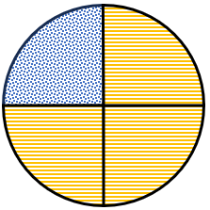

$$\frac{3}{4}$$
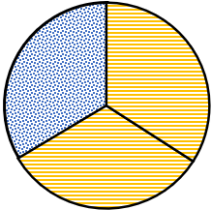

$$\frac{2}{3}$$
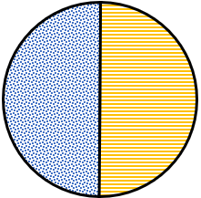
$$\frac{1}{2}$$

7 of 17 – Question 3
What fraction of this shape is green (striped)?

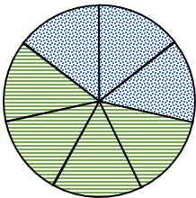

Select one answer: $\frac{1}{7}$ , $\frac{7}{4}$ , $\frac{4}{7}$ or $\frac{3}{7}$ .

Answer: $\frac{4}{7}$of this shape is green.

8 of 17 – Question 4
What fraction of this shape is orange (striped)?

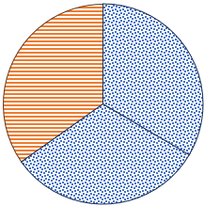

Select one answer: $\frac{1}{3}$ , $\frac{3}{3}$ , $\frac{2}{3}$ or $\frac{3}{1}$.

Answer: $\frac{1}{3}$of this shape is orange.

9 of 17 - Writing fractions in words
There are special words that we can use to describe fractions when we talk about them.
We say the numerator first as a whole number, then the denominator using its special word.

For example, this fraction: $\frac{4}{5}$

We would call this four fifths, where four is the numerator and fifths is the special word we use when the denominator is five.

10 of 17 - Words for fractions

Here are the words you’ll need to know to describe fractions of things up to ten parts.

Fraction | Word | Plural
$$\frac{1}{2}$$ | One half | Halves
$$\frac{1}{3}$$ | One third | Thirds
$$\frac{1}{4}$$ | One quarter | Quarters
$$\frac{1}{5}$$ | One fifth | Fifths
$$\frac{1}{6}$$ | One sixth | Sixths
$$\frac{1}{7}$$ | One seventh | Sevenths
$$\frac{1}{8}$$ | One eighth | Eighths
$$\frac{1}{9}$$ | One ninth | Ninths
$$\frac{1}{10}$$ | One tenth | Tenths

11 of 17 – Question 5
How is the fraction 4 over 5 described in words?

Select one answer.

- Five quarters
- Four fives
- Four fifths
- Five fourths

Answer:

The fraction 4 over 5 can be described in words as four fifths.

12 of 17 – Question 6
How is the fraction three sevenths written in numbers?

Select one answer: $\frac{7}{10}$ , $\frac{3}{7}$ , $\frac{7}{3}$ or $\frac{7}{30}$.

Answer:

"Three sevenths is written as $\frac{3}{7}$ .

13 of 17 – Question 7
What fraction of this shape is orange (striped)?

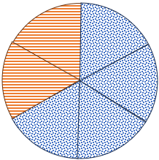

Select one answer.

- Three sixths
- Two sixths
- One sixth
- Six halves

Answer:

Two sixths of this shape is orange.

15 of 17 – Fraction problems
Fractions can help us to work out problems.

Shayla is having a birthday party. 24 people are coming. Half of them will walk, and a quarter of them travel by bus. The rest get a taxi.

We want to know how many people will walk, get a bus and take a taxi.

To work out how many people will walk to the party, you need to find half of 24.

To do this, divide 24 by 2.
24 ÷ 2 = 12 so 12 people will walk to the party.

To work out how many people will travel to the party by bus, you need to find a quarter of 24.

To do this, divide 24 by 4.
24 ÷ 4 = 6 so 6 people will take a bus to the party.

To work out how many people will take a taxi to the party, first you need to work out what fraction is represented by people taking a taxi.

We already know that half are walking, and a quarter are taking the bus, so that leaves a quarter taking a taxi.

To find a quarter of 24, divide it by 4.

24 ÷ 4 = 6 so 6 people will take a taxi to the party.

16 of 17 – Fraction problems – try for yourself
See if you can use fractions to solve this problem.

Sam has bought a bag of sweets. There are 30 sweets in the bag.
Two thirds of the sweets in the bag will be toffees.
The rest are sherbert lemons.

How many of the sweets are toffees, and how many are sherbert lemons?

See if you can work out the answer, then select the sweets to see if you were correct.

There are 20 toffees in the bag.

To work this out, divide 30 by three then multiply it by two.
30 ÷ 3 = 10, 10 x 2 = 20

There are 10 sherbert lemons in the bag.
To work this out we know that if 2/3 of the bag are toffees, 1/3 must be sherbert lemons.

Divide 30 by three to work out what one third is.
30 ÷ 3 = 10

17 of 17 – Conclusion
Well done. You have completed this session on fractions.

- You should now be able to:
- Recognise fractions from shapes
- Express fractions in words and numbers
- Work out simple fraction problems

If you have questions about any of the content covered in this session, please speak to your tutor.

