Maths L1 Refresh

Subtraction

1 of 17 – Introduction
Welcome to this session on Subtraction.
By the end of this session, you will be able to subtract whole numbers using the following methods:
- Number line method
- Formal written method
- Splitting method

2 of 17 – Addition
When you write a subtraction sum, you use the subtraction sign. It looks like a small horizontal line: –
We use different words to describe subtraction.
For example, 15-6=9 can be described as:
- 15 subtract 6 equals 9
- If you reduce 15 by 6 you get 9
- The difference between 15 and 6 is 9
- 15 take away 6 is 9
- 15 minus 6 is 9
- 6 is 9 fewer than 15
- 6 is 9 less than 15
- If you decrease 15 by 6 you get 9

3 of 17 – Number order and subtraction
With addition, it doesn’t matter which order the numbers are in
For example:
- 2 + 4 = 6 is the same as 4 + 2 = 6.
However, it DOES matter which order the numbers are in for subtraction.
For example:
- 8 – 6 = 2
- 6 – 8 = -2
These sums give different answers.

4 of 17 - Subtraction methods
There are different subtraction methods that you can use.
There is no method that is ‘right’ or ‘better’. You can use the method that works best for you.
In this session we will be learning about:
- The number line method
- The formal written method
- The splitting method

5 of 17 - Number line method
You can use a number line to help you do sums involving subtraction.
For example, imagine a line marked with numbers from -5 to 5.
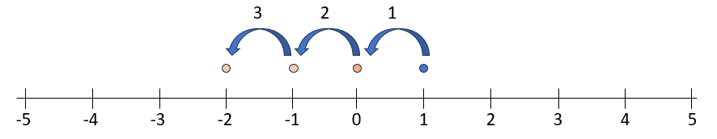
To work out the answer to 1 – 3:
- Find the number 1 on the number line
- Subtract 3 by moving left along the number line 3 places
- The answer is where you end up on the number line, which is -2
Therefore, 1 – 3 = -2.
6 of 17 - Jumps on a number line
You can make any "jumps" you want on a number line, to help solve a calculation.
For example, imagine a line marked with numbers from 0 to 20.
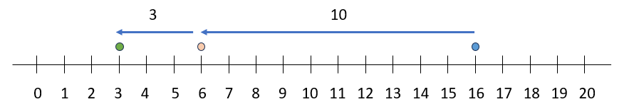
To work out the answer to 4 + 12:
- To work out the answer to 16 – 13:
- Find number 16 on the number line
- Jump left by 10 to the number 6
- Move left along the number line by another 3
- The answer is where you end up on the number line: 16 – 13 = 3

7 of 17 – Question 1
Which sum is being described here?
There is a number line marked with numbers from 0 to 20. The starting point is marked at number 19 and then “jumps” by 10 to the number 9. The point then moves along the number line by another 4, which ends at the number 5.
Select one answer.
- 10 – 4 = 6
- 19 – 10 = 9
- 9 – 14 = 5
- 9 – 4 = 5
Answer:
The sum being described here is 9 – 14 = 5

8 of 17 – Question 2
Which sum is being shown on this number line?
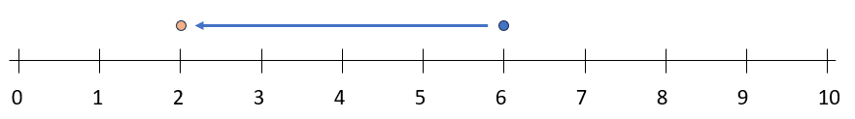
Select one answer.
- 6 – 2 = 4
- 6 – 4 = 2
- 8 – 2 = 6
- 6 – 2 – 2 = 2
Answer:
The sum being described here is 6 – 4 = 2.

9 of 17 - Formal written method
The formal written method of subtraction is useful for subtracting bigger numbers, and for subtracting more than two numbers.

When using the formal written method, it is important to line up the place values. Always start subtracting from the column on the right, and work towards the left.
Let’s use the example of 26 – 12 = 14. The steps below will walk you through working out the sum using the formal written method.
- Write the sum out so the units and tens are lined up. The units 6 and 2 are lined up in the same column and the tens 2 and 1 are lined up in the same column.
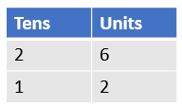
- Subtract the lower unit from the upper unit: 6 – 2 = 4. Put the answer in the units column, below the 2 and the 6.
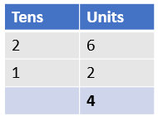
- Subtract the lower tens digit from the upper tens digit: 2 – 1 = 1. Put the answer in the tens column, below the 2 and 1.
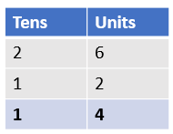
- The bottom row of the table shows us the answer. We have 1 ten and 4 units, so the answer is 14.

10 of 17 - Borrowing
When using the formal written method, you will sometimes need to subtract a larger number from a smaller number. In this case you will need to borrow (also called regrouping).
Let’s use the example of 32 – 17 = 15. The steps below will walk you through working out the sum using the formal written method.

- Write the sum out so the units and tens are lined up, like the example in the table. The units 2 and 7 are lined up in the same column and the tens 3 and 1 are lined up in the same column.
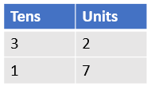
- You cannot subtract 7 from 2, so you need to ‘borrow’ ten from the tens column. To do this, reduce the tens figure by 1 (3 – 1 = 2) so that the number 2 replaces the number 3. You then need to increase the units figure by 10 (2 + 10 = 12) so that the number 12 replaces the number 2.
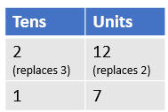
- Now you can subtract the lower unit from the upper unit: 12 – 7 = 5. Put the answer in the units column.
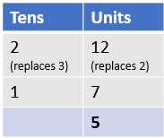
- Subtract the lower tens digit from the upper tens digit: 2 – 1 = 1. Put the answer in the tens column.
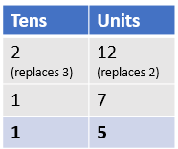
- We have 1 ten and 5 units, so the answer is 15.

11 of 17 – Question 3
For the sum 64 - 51 = choose the correct solution:
- 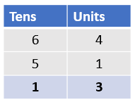
- 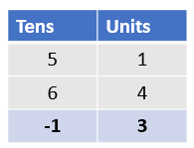
Answer:
This is the correct solution.

12 of 17 - Splitting method
The splitting method splits numbers according to place value.
For example:
123 would be split into 100 + 20 + 3
To perform the splitting method, follow these three steps:
- Split each number you are adding into units, tens and hundreds.
- Add together all the units, then add together all the tens, then add together all the hundreds.
- Add together the units total, tens total and hundreds total.
Brain Boost: Another name for the splitting method is partitioning.
Let’s look at an example: 160 – 34 = ?
First, split the 34 into 30 and 4.
- This makes the calculation: 160 – 30 – 4 = ?
Then, subtract the 30 from 160.
- 160 – 30 = 130
Finally, subtract the 4 from the 130.
- 130 – 4 = 126
The answer is 160 – 34 = 126

13 of 17 – Question 4
Which of these split sums is the same as the original sum 2000 – 128?
Select one answer.
- 2000 – 28
- 2000 – 100 – 20 – 8
- 200 – 100 – 20
- 200 – 100 – 8
Answer:
2000 – 128 is the same as 2000 – 100 – 20 – 8

14 of 17 - Opposite operators
Subtraction is the opposite action of addition.
When you carry out a subtraction you can check your answer using addition.
For example, we know that 10 – 3 = 7.
This means that 3 + 7 = 10 and 7 + 3 = 10.
Brain Boost: Operators are symbols that represent mathematical operations, such as addition (+), subtraction (-), multiplication (×), division (÷), or comparison (==, >, <).

15 of 17 – Question 5
Which two addition sums could be used to check the subtraction sum 19 – 6 = 13?
Choose all that apply:
- 13 + 6 = 19
- 6 + 13 = 19
- 19 + 13 = 32
- 6 + 19 = 25
Answer:
13 + 6 = 19 and 6 + 13 = 19 can be used to check the sum 19 – 6 = 13.

16 of 17 – Question 7
Pierre is using the addition 23 + 3 = 26 to check his workings for its opposite subtraction.
Which sums could he be checking?
Select one answer.
- 26 - 3 = 23
- 23 – 26 = -3
- 26 – 23 = 3
- -3 - 23 = -26
Answer:
Pierre could be checking either 26 - 3 = 23 or 26 – 23 = 3.

17 of 17 – Conclusion
Well done. You have completed this session on subtraction.
You should now be able to subtract whole numbers using the following methods:
- Number line method
- Formal written method
- Splitting method
If you have questions about any of the content covered in this session, please speak to your tutor.

