Maths L1 – Bar Charts

1 of 15 – Welcome
Welcome to this session on bar charts.
By the end of this session, you will be able to:
- Explain what a bar chart is
- Describe what titles and axis labels show
- Read information from bar charts
- Explain why bar charts are useful

2 of 15 – What is a bar chart?
Bar charts are used to make comparisons and to illustrate the relationship between items of information in terms of size.
Bar charts are useful because:
- They present information in a clear, systematic way
- It is easier to see relationships, patterns or trends
- People take in visual information more clearly and quickly than words
- You can make comparisons more easily
Bar charts display simple results clearly, but are not generally useful for large amounts of structured information.

3 of 15 – Labelling a bar chart
All bar charts should be easy to read and understand.
A bar chart should always have:
- A title that tells you what the bar chart is about
- A sensible scale so that it is easy to read
- A label for the x axis (horizontal axis)
- A label for the y axis (vertical axis)

4 of 15 – Question 1
What is missing from the bar chart?
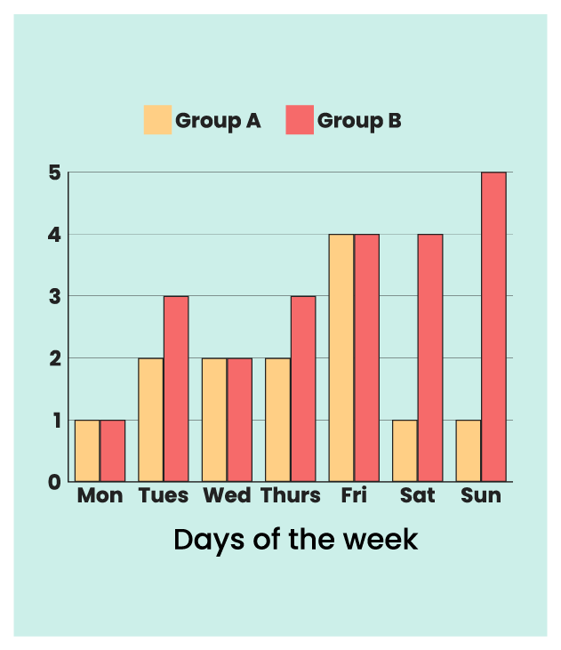
Select all that apply.
- Title
- Scale
- Label for y (vertical) axis
- Label for x (horizontal) axis
Answer: The correct answers are a and c. The bar chart is missing a title and a label for the y (vertical axis).

5 of 15 – Bar charts
Bar charts can be used to show amounts of things in a visual way.
For example, this bar chart shows the number of cars sold in a week, sorted by colour.
- The horizontal axis shows the number of cars sold
- The vertical axis shows the colours of cars
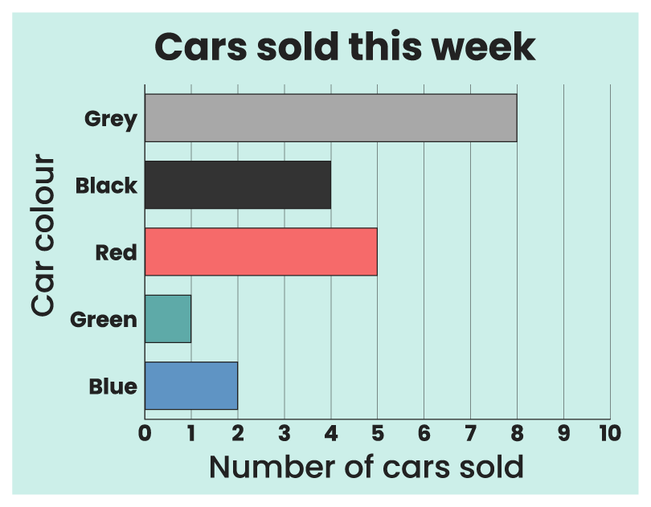

6 of 15 – XXXX
To interpret the information in a bar chart, you need to be able to read it. Bar charts show the relationship between categories of information and their values, represented by the x and y axis.

One axis of the chart will be used to represent the categories of data being compared. This could be days of the week, eye colour or favourite film, for example.

The other axis of the chart represents the values of the data. This could be numbers of things, temperatures, percentages or any other numerical quantity.

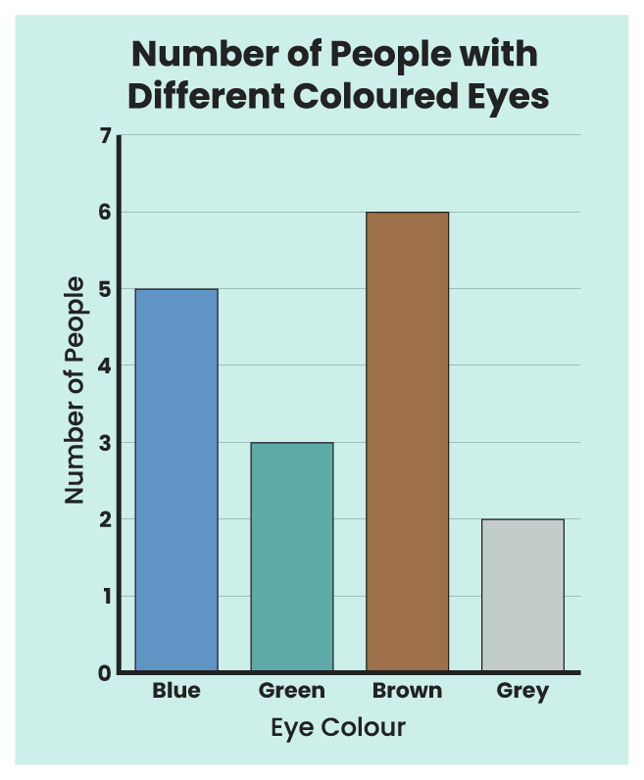

The chart contains information by combining these two axes together. For example, if there were five people who had blue eyes, one bar of the chart will be aligned with the “blue eyes” part of one axis, and will reach to “5” on the other axis.

7 of 15 – Question 2
According to this bar chart, how many people own a dog?
Select one answer.
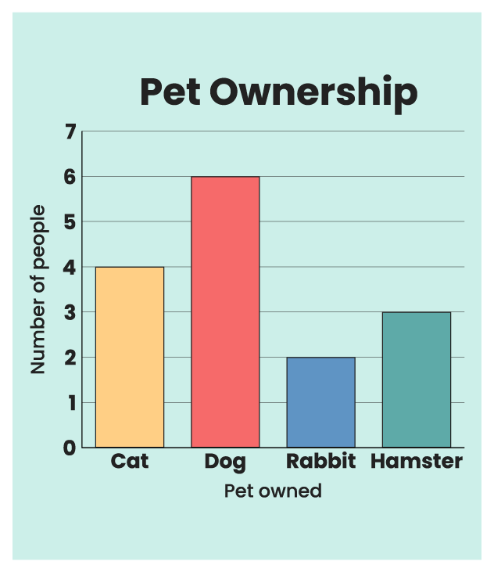
- 4
- 6
- 2
- 3
Answer: According to the chart, 6 people own a dog. You can tell this because the bar for “dog” goes up to the value “6”.

8 of 15 – Question 3
According to this bar chart, how many people like tuna sandwiches most?
Select one answer.
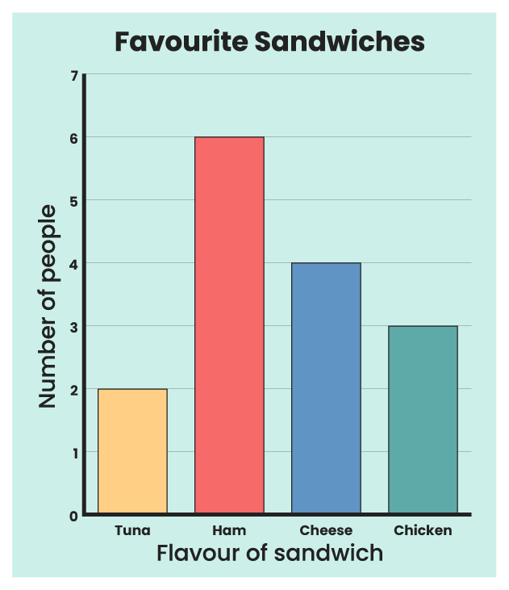
- 2
- 3
- 4
- 6
Answer: According to the chart, 2 people like tuna sandwiches most. You can tell this because the bar for “tuna” goes up to the value “2”.

9 of 15 – Reading in between values
If the values represented by the chart are high, you might not see every number listed on the axis. This means that the height of the bar might not match exactly with a value that is written onto the axis.
When this happens, you need to look at the scale and work out what the intervals are between each number. For example, if the scale counts up in twos, you would know that a bar that finished halfway between 8 and 10 would be representing the number 9.

10 of 15 – Question 4
According to this bar chart, what was the temperature on Friday?
- 14ºC
- 11ºC
- 9ºC
- 16ºC
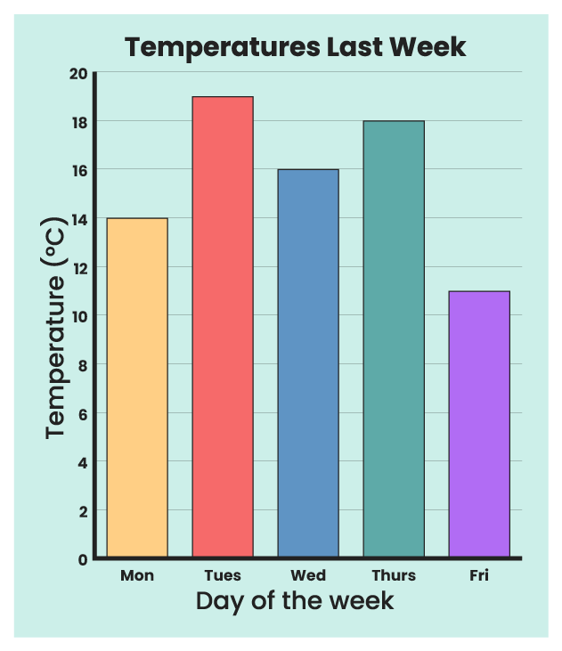
Answer: According to the chart, the temperature on Friday was 11ºC. You can tell this because the bar for Friday goes up to halfway between the 10 and 12 markers, so it must represent 11.

11 of 15 – Axis labels
The labels on the axes are very important, because they tell you what type of information is being shown on each axis.
Where values are measurements, the axis label should also include units that the values are being given in. These will usually be shown in brackets.
Some examples of axis labels are:
- Distance (cm)
- Time (seconds)
- Number of people
- Favourite colour

12 of 15 – Chart titles
The title of a bar chart should tell you what the bar chart is about. It should make it clear what information is being shown in the chart.
A good title combines the information from the axis labels to describe the information that the bar chart is showing you, along with any additional context or information that you need to know.
For example, a chart that has one axis labelled “Number of Medals” and another labelled “Countries” is about the number of medals each country has won.

13 of 15 – Question 5
Which of these titles could be used to describe this bar chart?
Select one answer.
- What Fantasy Creatures Like to Eat
- Fantasy Creatures Most Likely to Win Awards
- Favourite Chocolate Bars in Our Class
- Favourite Fantasy Creatures in Our Class
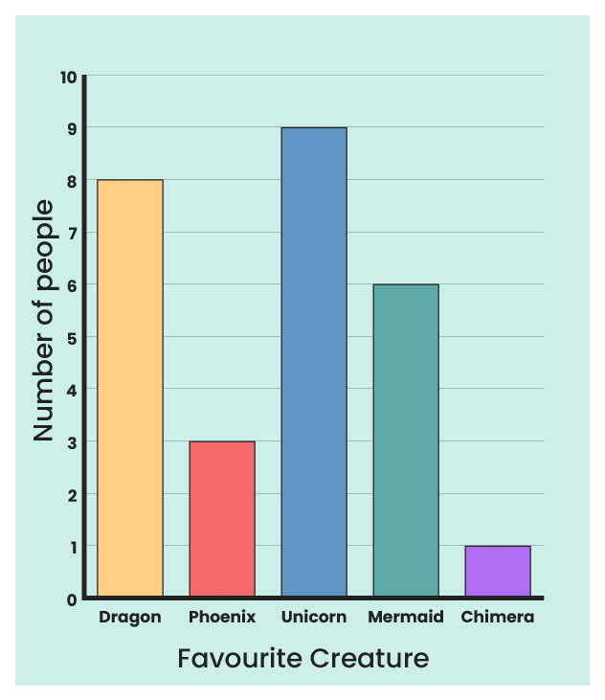
Answer: This bar chart could be called “Favourite Fantasy Creatures in Our Class” because it is describing the number of people who like various fantasy creatures.

14 of 15 – Discrete and continuous data
There are two types of data that bar charts can represent. We call these discrete and continuous.
Discrete bar charts are used to show data that changes in whole units. They can be used to compare different categories or groups. The bars do not touch each other because each one stands for a separate category. For example, if you want to show how many people like different flavours of ice cream, each bar would show a different flavours such as chocolate, vanilla, or strawberry.
Continuous bar charts, also called histograms, are used to show data that changes continuously along a line. They can be used to show how often things happen within certain ranges. The bars touch each other because they represent ranges of numbers (like 0-10, 11-20). For example, if you have test scores from 0 to 100, a histogram can show how many students scored between 0-10, 11-20, and so on.

15 of 15 – Question 6
Does this bar chart show discrete or continuous data?
Select one answer.
- Discrete
- Continuous
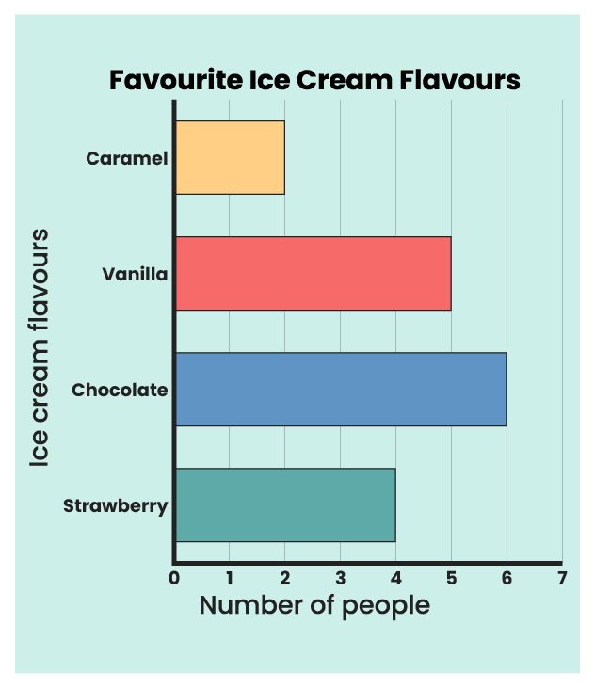
Answer: This bar chart shows discrete data, because the bars do not touch.

15 of 15 – End
Well done. You have completed this session on bar charts.
You should now be able to:
- Explain what a bar chart is
- Describe what titles and axis labels show
- Read information from bar charts
- Explain why bar charts are useful
If you have questions about any of the content covered in this session, please speak to your tutor.
Please use the ‘close session’ button on the following slide or your progress may not be recorded.
If you have any questions about the topics covered in this session, please speak to your tutor or line manager.

